**Website layout**

1. Home

* different sections of homepage (will lead to a new page if a div is clicked)

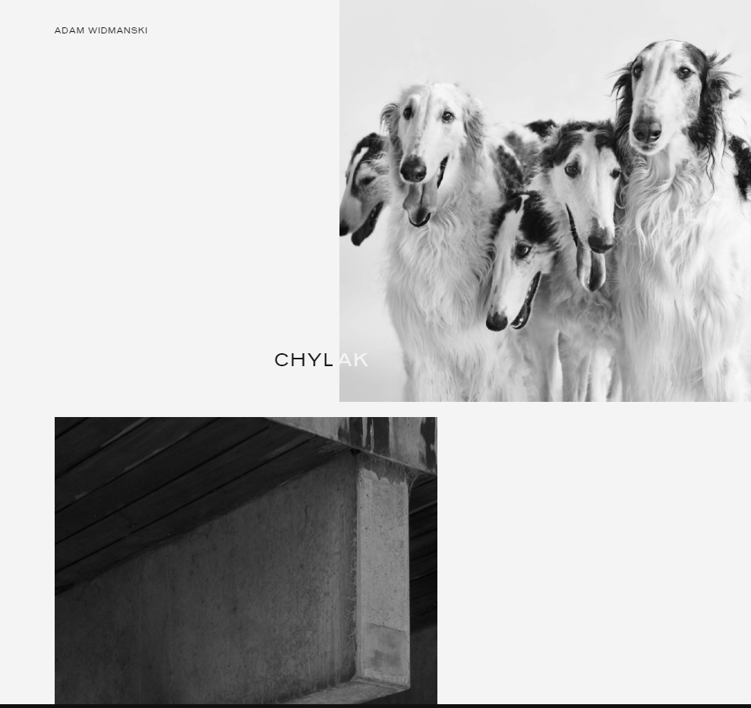

* 1. Dog breed
* 2. Find the dog
* 3. dog food care and advices
* 4. dog games: /dog news

1. Breed

* show different breeds of dogs, will open a pop-up window of the breed details when clicked

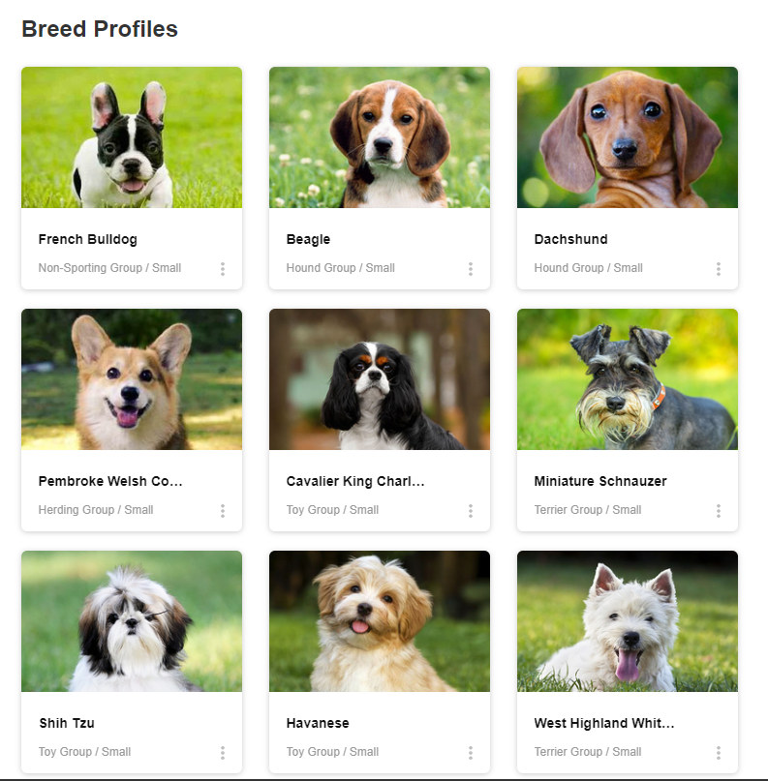

* filter section for user to search a specific breed

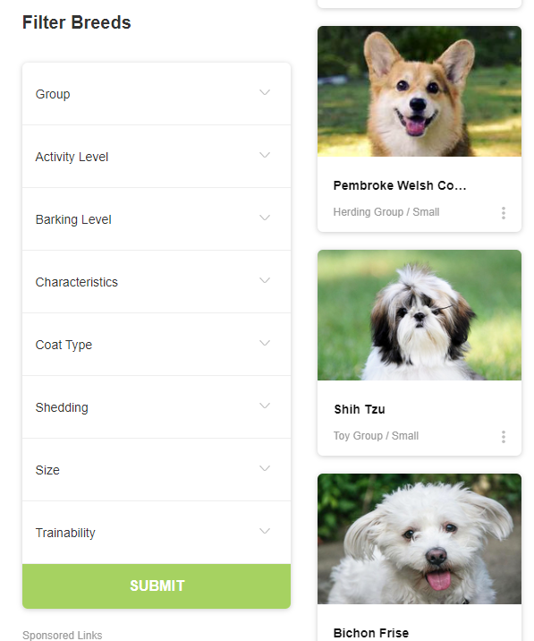

* Dog food care and advices

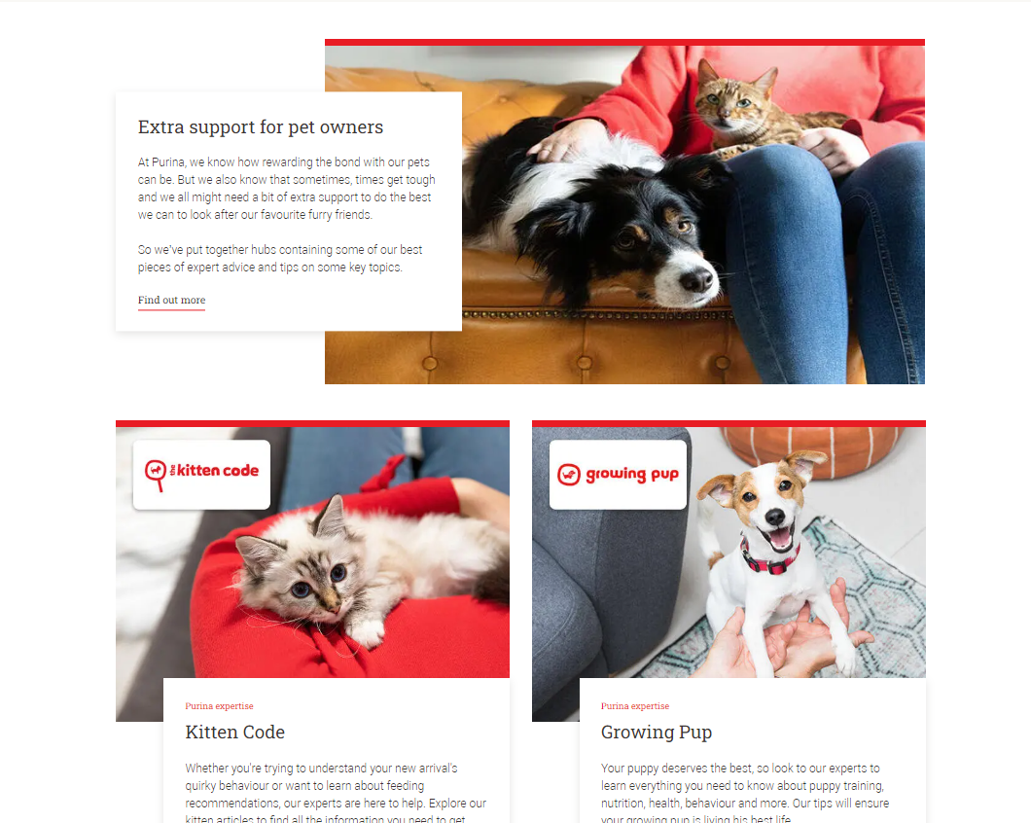

* Dog games:/ dog news

